

**SCHOOL OF PHYSICS**

# UNIVERSITI SAINS MALAYSIA

**ZCT191/192 PHYSICS PRACTICAL I/II**

1GP1 DYNAMICS

***Lab Manual***

# OBJECTIVES

1. *To determine the gravitational acceleration (*𝑔*) by studying the free fall of a body.*
2. *To study the relationship between the velocity and mass of a glider when its kinetic and potential energies are fixed.*
3. *To study the concept of conservation of momentum and energy through the collision between two bodies.*

# THEORY

## Gravitational Force

Gravitation is the force of attraction that exists between all particles with mass in the Universe. It is the force of gravity which is responsible for holding objects onto the surface of planets, and Newton's law of inertia responsible for keeping objects in orbit around one another.

"*Gravity is the force that pulls you down*." – Merlin in Disney's *The Sword in the Stone*

Merlin was right, of course, but gravity does much more than just holding you in your chair. It was the genius of Isaac Newton to recognise this. Newton recalled in a late memoir that while he was trying to figure out what kept the Moon in the sky, he saw an apple fall to the ground in his orchard. Only then he realised that the Moon was not suspended in the sky, but continuously falling, like a cannon ball that was shot so fast it continuously misses the ground as it falls away due to the curvature of the Earth.

According to Newton's third law, any two objects exert equal and oppositely directed gravitational pulls on each other. Isaac Newton was the first scientist to define gravity mathematically when he formulated his law of universal gravitation. The law of gravitation says that gravity is strongest between two very massive objects, and gets much weaker as these objects get further apart.

## Free Fall

A body in free fall such as a sphere in this experiment will be accelerated because of the Earth’s gravitational force. For this experiment, we can assume that the acceleration by the gravity 𝑔 is constant. If the initial velocity of a body is zero, the time 𝑡 taken for the sphere to pass a distance

𝑑 can be expressed using the equation

|  |  |
| --- | --- |
| 1  𝑑 = 𝑔𝑡2.  2 | (1) |

The value of 𝑔 can be determined by making a suitable measurement for 𝑑 and 𝑡.

We make many assumptions when using **Equation 1** to determine 𝑔, one of them is that we assume there are no systematic errors in the time measurements. Besides, in many mechanics and electrical systems, there will be a time delay in measurement, since the system does not react immediately. So, the recorded time 𝑡̅ by the timer may be different from the actual time taken by the sphere to fall along the distance 𝑑. If the time delay Δ𝑡 is constant, we have

|  |  |
| --- | --- |
| 𝑡̅ = 𝑡 + Δ𝑡, | (2) |

where 𝑡 is the actual time for the sphere to fall down along the distance 𝑑. So, **Equation 1** now becomes

|  |  |
| --- | --- |
| 1  𝑑 = 𝑔(𝑡̅ − Δ𝑡)2, 2 | (3) |

or

|  |  |
| --- | --- |
| 2 1  𝑡̅ = √ 𝑑2 + Δ𝑡.  𝑔 | (4) |

In the arrangement of the equipment used in this experiment, you will see that there are various systematic errors in your measurement. You must find a way to minimise them by making observations and recognising the error sources.

## Conservation of Momentum

The *conservation of momentum* is a fundamental concept of physics along with the conservation of energy and the conservation of mass. Momentum (𝑝) is defined to be the mass of an object multiplied by the velocity of the object, 𝑝 = 𝑚𝑣. The conservation of momentum states that within a problem domain, the amount of momentum remains constant; momentum is neither created nor destroyed, but only changed through the action of forces as described by Newton's laws of motion.

Dealing with momentum is more difficult than dealing with mass and energy because momentum is a vector quantity, having both a magnitude and a direction. Momentum is conserved in all three physical directions at the same time. It is even more difficult when dealing with a gas because forces in one direction can affect the momentum in another direction, causing collisions among the many molecules.

The law of momentum conservation is one of the most powerful laws in physics. The law of momentum conservation can be summarised as follows:

*For a collision occurring between object 1 and object 2 in an isolated system, the total momentum of the two objects before the collision is equal to the total momentum of the two objects after the collision.*

## Air Track Collision

An *air track* is a track without any friction, it is used to study the movement of any object in a straight line. An air source from a vacuum blower is directed into the tube of the triangular track to support the glider that moves across it. The air source must be placed as close as possible as it is needed to support the gliders. A 100 g load (given in the box) is placed on the glider before the spindle at the vacuum equipment, so that a load of at least 100 g can be supported by the air without friction.

An air track must first be adjusted to level horizontally by using a water bubble level. Then, the air source is turned on, and an unloaded glider is placed on the track to for further calibration: the glider should be floating statically and should not move to the left or right. Some rubber bands should be placed at both ends of the air track to prevent the gliders from colliding the end of the track.

In this experiment, the glider velocity is determined using a *photogate*. A card can be placed on the glider to block the light beam from shinning in the photogate, which triggers the timer. When this light beam is blocked, the timer will start counting until the glider passes it and the light beam resumes. In this way, the glider’s velocity can be calculated from the time measured and the card length.

## Potential Energy and Kinetic Energy

Rubber bands can be used to supply a *potential energy* to the gliders. The potential energy of the rubber bands is given by

|  |  |
| --- | --- |
| 𝐸𝑃 = 𝑛𝜀, | (5) |

where 𝑛 is the number of the rubber bands and 𝜀 is the energy in each rubber band. The kinetic energy for the glider is given by

|  |  |
| --- | --- |
| 𝐸 = 1 𝑚𝑣2,  𝐾 2 | (6) |

where 𝑚 is the glider mass and 𝑣 is the glider velocity. By equating equations (5) and (6), we get:

|  |  |
| --- | --- |
| 1  𝑣2 = 2𝑛𝜀 ,  𝑚 | (7) |

In this experiment, the number of rubber band is fixed. The potential energy of the rubber band 𝜀, is also fixed by stretching the rubber band at the same suitable distance every time. The glider mass is changed and the value of 𝑣 corresponding to the mass changed can be determined.

# EQUIPMENT

## PART A

1. Metre rule
2. Timer
3. Griffin ‘g’ with free fall
4. 9/12 V adapter
5. Steel sphere
6. Retort holder and sphere holder

## PART B and PART C

1. Air track system with 2 gliders
2. 2 photogates (one with timer and the other one without)
3. Plasticine
4. Weighing scale

# PROCEDURE

**Part A: Free Fall of a Body**

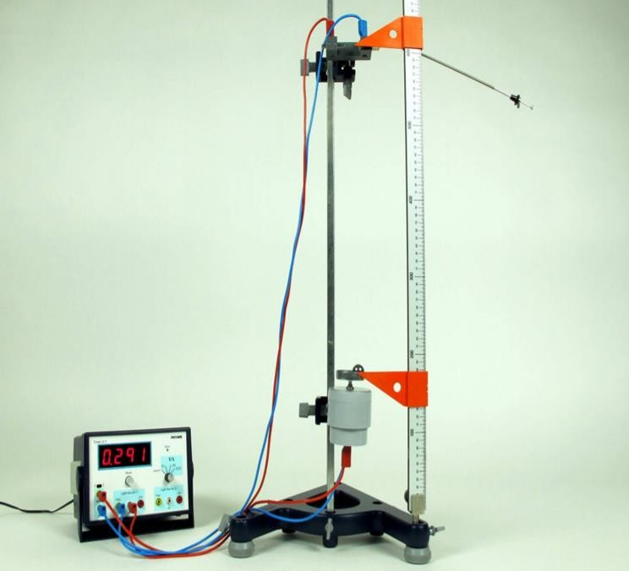

**Figure 1**: Equipment set up for Part A.

A small steel sphere is used as a body which will undergo free fall. A sphere holder is set up in a retort holder and a receiver plate is connected to the timer.

1. Measure and record the mass and diameter of the steel sphere given.
2. Set up the equipment as shown in **Figure 1**. Start with a distance of 𝑑 = 10 cm.
3. Put the steel sphere on the holder by pulling the dowel pin. Reset the timer to zero.
4. Let the dowel pin free, this action will cause the sphere to fall. Record the time 𝑡 taken for the sphere to fall on the receiver plate.
5. Practice steps 3 and 4 for a few times. Once you are ready, repeat the process and take the 10 readings without discarding any readings which you may think is not precise.
6. Repeat steps 3 and 4 by changing the distance 𝑑 to these values: 12, 15, 17, 20, 23, 25, 27, 30, 32, 35, 37 and 40 (cm).
7. Record the data in the table given in **WORKSHEET 1**. **WORKSHEET 1** must be clipped together with your report and certified by the lab officer.

## Data Analysis and Calculation

1

1. Using a suitable equation, sketch the graph of 𝑡̅ versus 𝑑2. Determine the value of 𝑔. and

Δ𝑡 from the graph.

1. Find the slope of the graph. Calculate the error for the value of 𝑔, and sketch error bars in your graph.
2. Compare your result value of 𝑔 with the standard value. Discuss your results and the possible errors that exist in this experiment.
3. Complete and submit your report in **Part A** at the end of the first week of the laboratory session. Your report must contain the title of the experiment, the objectives, equipment, data, graph calculations, error analysis, discussion and conclusion.

# Part B: Air Track System with One Glider

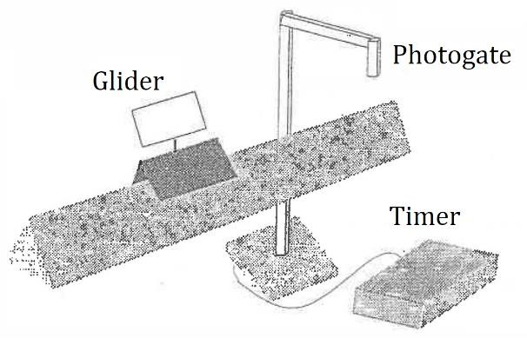In the following two parts, you will study about the features of moving objects in straight horizontal directions. In this part, you will study the change from *potential energy* (rubber bands) to *kinetic energy* (glider). We will also measure the glider velocity and mass to study the conservation of energy. Use 2 or 3 new rubber bands each time you start the experiment.

**Figure 2**: Equipment set up for Part B.

1. Set up the instruments as described in the **THEORY** section and as shown in **Figure 2**, connecting only one phototransistor to the timer. Put the phototransistor at the place where you think is suitable.
2. Adjust the air track such that it is levelled with the water bubble level, and test it with a glider.
3. Measure and record the card length, then measure the mass of one glider without any load. After that, place the glider at the end of the air track.
4. Stretch the rubber band by pushing the glider between 1 to 2 cm. Note that the stretched distance of the rubber band should be fixed in this experiment to get consistent results.
5. Set the photogate timer to **GATE** mode, and press the **RESET** buttons. Let the glider free and record the time after the glider passed the photogate timer once. Do not let the glider return back!
6. Reset the photogate timer to zero again, and repeat the previous step up to 6 times.
7. Change the mass of the glider by adding weights, then repeat steps 5 and 6. Do this for at least 8 different masses. You can increase the mass of the glider by using plasticine in steps between 10 to 20 g. It is not necessary to increase the mass in fixed values each time.
8. Record all the data in the table given in **WORKSHEET 2 – PART B**. Clip this data sheet together with your report and it should be verified by the lab assistant.

## Data Analysis and Calculation

1. Plot the graph of 𝑣2 versus 1/𝑚 and determine whether your graph agrees with Eq. (7). Calculate the errors involved and sketch the error bars on your graph.
2. Find the slope from the graph.
3. Calculate the potential energy 𝜀 for each rubber band.

# Part C: Air Track System with Two Gliders

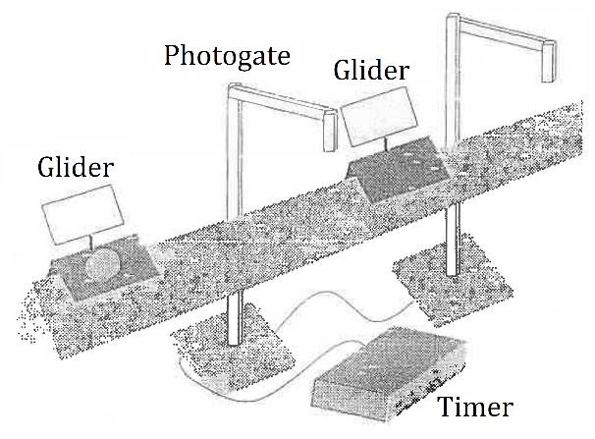This part is a little different from **PART B**. Here, you will study the conservation of momentum and energy for the collision between two gliders with different masses.

**Figure 3**: Equipment set up for Part C.

1. Set up the instrument as described in the **THEORY** section as shown in **Figure 3**.
2. Set up 2 photogates (one with timer and the other without), and place a glider without any load (known as the ‘small glider’ from here onwards) between the two photogates, which are placed a suitable distance apart.
3. Add 100 g to another glider (known as the ‘big glider’ from here onwards) and place it at the end of the air track.
4. Displace the big glider with a suitable stretch distance from the rubber band so that timer can measure the following times:
   1. The time required for the big glider to pass photogate 1 before collision;
   2. The time required for the small glider to pass photogate 2 after collision; and
   3. The time required for the big glider to pass any photogate after collision.

Note that the collision must occur after the big glider has passed completely through photogate 1, and after collision both gliders must be fully separated before either glider passes a photogate.

1. Set the photogate timer to **GATE** mode, and press the **RESET** button. Take 6 sets of data for each run. Note that you can use the memory function to store the initial times while the final times are being measured.
2. Record all the data in the table given in **WORKSHEET 2 – PART C**.

## Analysis and Calculation

1. Calculate
   1. The velocity 𝑣1 of the big glider before collision;
   2. The velocity 𝑣2 of small glider after collision; and
   3. The velocity 𝑣3 of big glider after collision.
2. Determine whether the momentum before and after the collision is conserved.
3. Determine whether the kinetic energy before and after collision is conserved.
4. Calculate the error involved in your calculation.
5. Complete and submit your report for **PART B** and **PART C** at the end of the laboratory session of your second week. Your report must contain the title, objectives, equipment, data, graphs, calculations, error analysis, discussion and conclusion.

# REFERENCES

1. Halliday, D., Resnick, R. and Walker, J. (2003). *Fundamentals of Physics (10th Edition)*, John Wiley & Sons.
2. Cutnell, J. D. and Johnson, K. W. (2009). *Physics (8th Edition)*, John Wiley & Sons.

**ACKNOWLEDGEMENT**

The original creator of this lab manual is unknown. This manual was revised and standardised by *Dr. John Soo Yue Han* in 2020, edited by *Dr. Nur Azwin Ismail* in 2020 and *Dr. Suhana Arshad* in 2021.

*Last updated*: 22 October 2023 (JSYH)

**DYNAMICS WORKSHEET 1**

*Instructions*: please complete **Worksheet 1** by the end of the first session of your experiment.

Name : _ Date :

Partner’s Name : Group :

# Part A

**Table 1**: Data table for PART A.

|  |  |  |  |  |  |  |  |  |  |  |  |  |
| --- | --- | --- | --- | --- | --- | --- | --- | --- | --- | --- | --- | --- |
| 𝒅  **(cm)** | 𝟏  𝒅𝟐 | **Time,** 𝒕 **(s)** | | | | | | | | | | |
| 𝒕𝟏 | 𝒕𝟐 | 𝒕𝟑 | 𝒕𝟒 | 𝒕𝟓 | 𝒕𝟔 | 𝒕𝟕 | 𝒕𝟖 | 𝒕𝟗 | 𝒕𝟏𝟎 | 𝒕̅ |
| **10** | **3.2** |  |  |  |  |  |  |  |  |  |  |  |
| **12** | **3.5** |  |  |  |  |  |  |  |  |  |  |  |
| **15** | **3.9** |  |  |  |  |  |  |  |  |  |  |  |
| **17** | **4.1** |  |  |  |  |  |  |  |  |  |  |  |
| **20** | **4.5** |  |  |  |  |  |  |  |  |  |  |  |
| **23** | **4.8** |  |  |  |  |  |  |  |  |  |  |  |
| **25** | **5.0** |  |  |  |  |  |  |  |  |  |  |  |
| **27** | **5.2** |  |  |  |  |  |  |  |  |  |  |  |
| **30** | **5.5** |  |  |  |  |  |  |  |  |  |  |  |
| **32** | **5.7** |  |  |  |  |  |  |  |  |  |  |  |
| **35** | **5.9** |  |  |  |  |  |  |  |  |  |  |  |
| **37** | **6.1** |  |  |  |  |  |  |  |  |  |  |  |
| **40** | **6.3** |  |  |  |  |  |  |  |  |  |  |  |

**DYNAMICS WORKSHEET 2**

*Instructions*: please complete **Worksheet 2** by the end of the second session of your experiment.

Name : _ Date :

Partner’s Name : Group :

# Part B

Mass of unloaded glider : g Length of card : cm

**Table 2:** Data table for **PART B**.

|  |  |  |  |  |  |  |  |  |  |  |
| --- | --- | --- | --- | --- | --- | --- | --- | --- | --- | --- |
| 𝒎  **(g)** | 𝟏  𝒎 | **Time,** 𝒕 **(s)** | | | | | | | 𝒗  **(**𝐜𝐦 𝐬−𝟏**)** | 𝒗𝟐 |
| 𝒕𝟏 | 𝒕𝟐 | 𝒕𝟑 | 𝒕𝟒 | 𝒕𝟓 | 𝒕𝟔 | 𝒕̅ |
|  |  |  |  |  |  |  |  |  |  |  |
|  |  |  |  |  |  |  |  |  |  |  |
|  |  |  |  |  |  |  |  |  |  |  |
|  |  |  |  |  |  |  |  |  |  |  |
|  |  |  |  |  |  |  |  |  |  |  |
|  |  |  |  |  |  |  |  |  |  |  |
|  |  |  |  |  |  |  |  |  |  |  |
|  |  |  |  |  |  |  |  |  |  |  |

# Part C

**Table 3:** Data table for **PART C**.

|  |  |  |  |  |  |  |  |
| --- | --- | --- | --- | --- | --- | --- | --- |
| **Photogate Passes** | **Time (s)** | | | | | | **Average Time,**  𝒕̅ **(s)** |
| 𝒕𝟏 | 𝒕𝟐 | 𝒕𝟑 | 𝒕𝟒 | 𝒕𝟓 | 𝒕𝟔 |
| **Big Glider**  **(before collision)** |  |  |  |  |  |  |  |
| **Small Glider**  **(after collision)** |  |  |  |  |  |  |  |
| **Big Glider**  **(after collision)** |  |  |  |  |  |  |  |